ST. XAVIER’S COLLEGE

**Maitighar,Kathmandu**

**(Affiliated to Tribhuvan University)**



**Database Management System**

**Lab Assignment #**

**Submitted By**

Ajita Khatiwada

B.Sc. CSIT

Year II/IV Semester

013BSCIT004

**Submitted To**

Er. Sanjay Kumar Yadav

Lecturer,

Department of Computer Science

St. Xavier’s College

Maitighar, Kathmandu

**Submitted On**

September 27, 2015

1 Selection in sql:

Syntax : **select…**display colomns **from** table **where …** conditions.

Q1. Find the eno,ename of the employee whose salary is >4000.

Syntax : **select** eno,ename,salary **from** employee **where** salary>4000

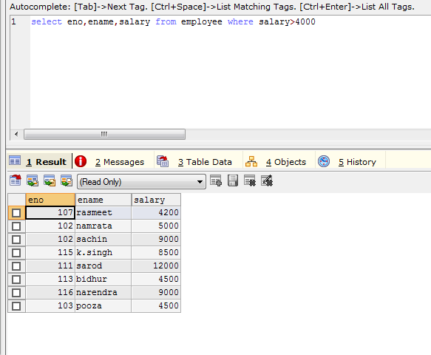

2. **Combining conditions and Boolean operations**

Q2. Find eno,ename ,salary of the employees whose salary is greater than 5000 and job status is professor .

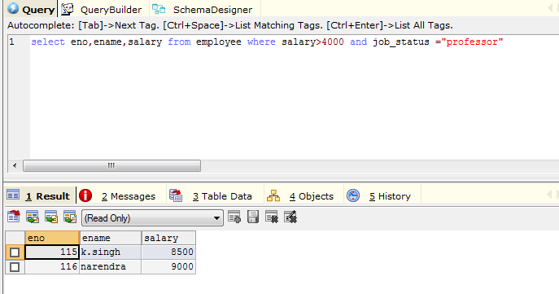

Q3 .Find the eno,ename ,salary of the employees whose department no is 20 or job status is research fellow

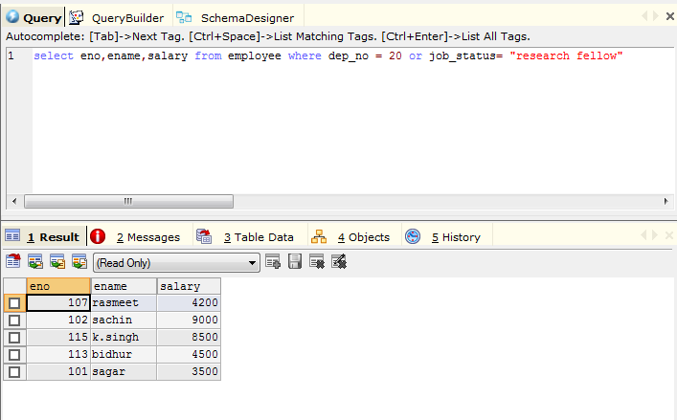

\***removing duplicates**

To Select address from employee.

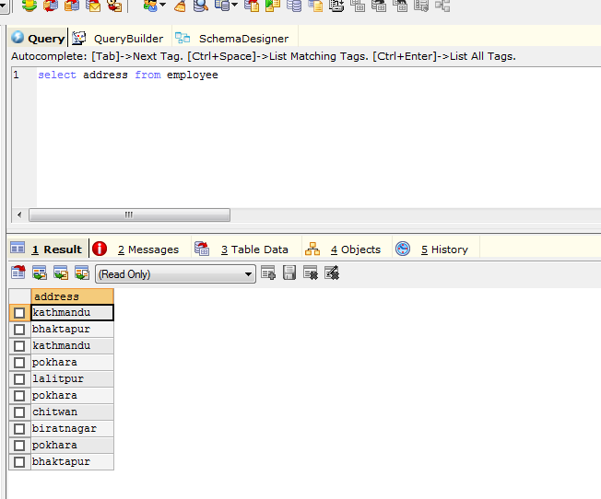

To select distinct address from employee

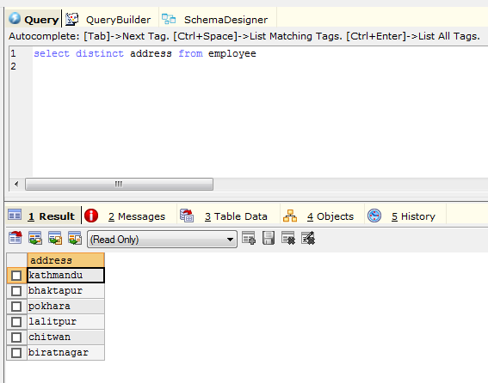

\***range specification**

Q4 find the eno,ename,age and salary from the employees where the age is between 24 and 28

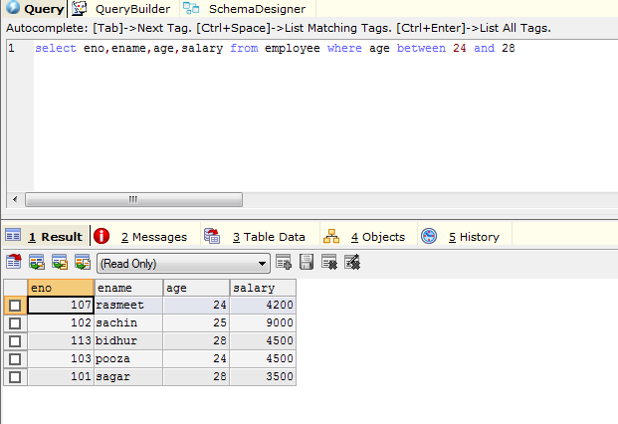

\***string operation** ( like , %)

* ‘ABC%’: all strings that starts with ABC eg : ABC and ABCD .
* '%XYZ’: all strings that end with XYZ. For eg: WXYZ & ZZXYZ.
* ‘%AN%’: all strings that contain the pattern AN anywhere. For eg : LOS ANGELES,SANFRANSISCO.

Q5. Find eno,ename whose name starts with SA

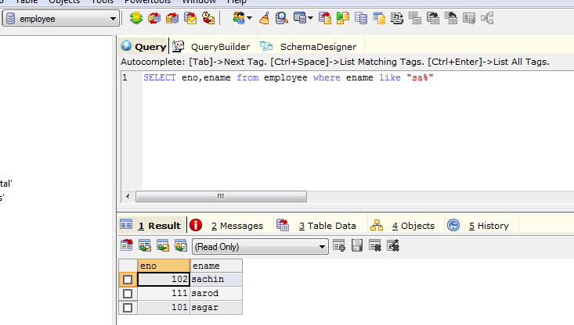

Q6. List all employee ename with their project name

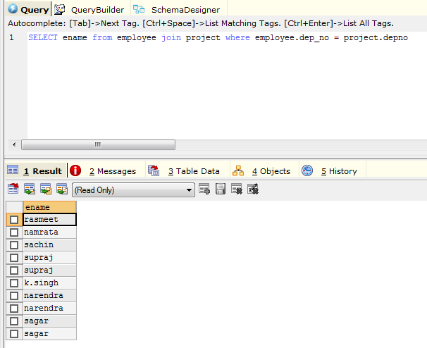

Q7 list name of all employees and their salary who are working in project mars or venus

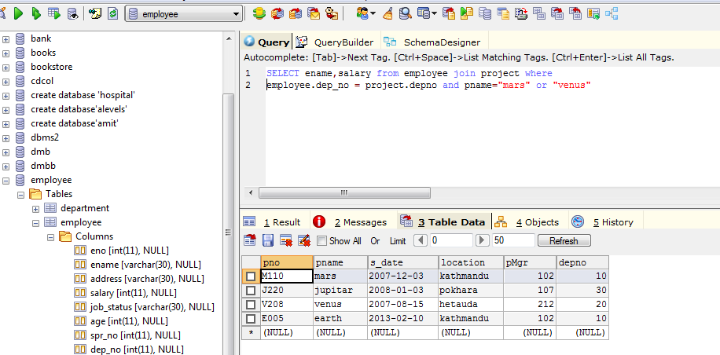

Q8 list name of all employee and their salary who are working in project earth and venus

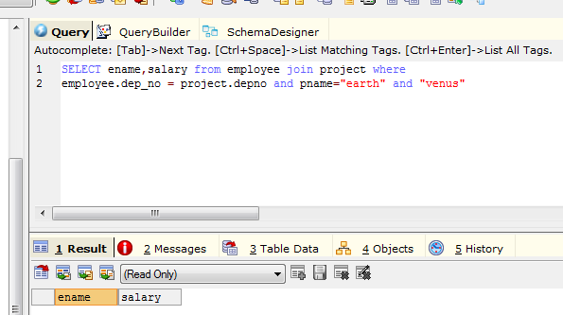

Q9 list name and address of all employee who works in department which is located in pokhara

